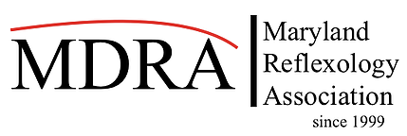
Maryland Reflexology Association
www.marylandreflexology.org
Membership Year: July 1, 2021 - June 30, 2022

Name ___________________________________ Email:____________________________________
Office Address:_________________________________________County_______________________
Home Address:_________________________________________County:______________________
Website Address:___________________________________________________________________
Office Phone:_______________________________ Home Phone:____________________________
Please Note: Complete all information as you would like it to appear on the MDRA website. Please check the following box if you do not wish your name to be added to the MDRS website.
- No, I do not want to be included on the MDRA website

Please select the membership that is appropriate to your education level

- Professional Membership $50 per year
Professional Membership requires successful completion of training from a school of reflexology and successful passing and maintaining obligations to ARCB.

- Practitioner Membership $50 per year
Practitioner Member requires successful completion of 110 hrs of reflexology training from a reflexology school.

- Advocate / Student Membership $25 per year
Advocate/Student Membership is open to any non certified reflexologist, student training in reflexology, clients or other interested persons.

School Name:______________________________Teacher Name:__________________________
Address:________________________________________________________________________
Phone:____________________No. Of Hours Completed:________Date of Completion:__________
Are you nationally certified by ARCB? ____ Yes _____ No Certification # ________________

I want to be an MDRA __volunteer __membership __newsletter __conference __delegate __other

I verify that I have met the requirements for the level of membership which I am applying and I have included all required documentation. I understand that if any of the above information is found to be in correct or invalid, my membership will be denied.
Signature:_____________________________________Date:_______________________

*** Payment due on or before June 30, 2021*** You may pay via PayPal or check. Make checks payable to Maryland Reflexology Association, ℅ Caroline Klem, 80 Via Barcaza, Trabuco Canyon, CA 92679.

